## Section 1: Company Overview

Other than the fact it is currently the biggest player in the industry, Spotify is a remarkable and wildly successful streaming platform in which its users can access millions of tracks and other media from artists worldwide. It also offers podcasts and streaming media capabilities. The innovative company and its leaders have driven Spotify from being a small start-up to dominating the market globally. The industry segment for Spotify is *Music Streaming Services in the US* and the industry code is OD6193 (*At a Glance: Music Streaming Services in the US,* IBISWorld, 2023). To summarize a brief history of the company, Steve Alexander of *Encyclopaedia Britannica,* writes that dating back to Spotify’s launch in 2008 as a small-sized start-up in the city of Stockholm, Sweden, innovators Daniel Ek and Martin Lorentzon founded the company with a license to stream music as opposed to the traditional music download services such as Apple’s iTunes platform (Alexander, 2023). Additionally, Alexander writes it was founded in order to “discourage online music piracy” and “provide a low-cost alternative” to other music platforms (Alexander). The Founder, CEO & Chairman of Spotify is Daniel G. Ek. Other key leadership at this company includes Paul Vogel, Chief Financial Officer; Alex Norström, Chief Business Officer and Co-President; Gustav Söderström, Co-President, Chief Product & Technology Officer; Sven Martin Lorentzon, Co-Founder & Director; and Bryan Daniel Goldberg, Head of Investor Relations (Spotify Technology S.A., S&P Capital IQ, 2023). The mission and vision statement from the Spotify website is as follows, “Our mission is to unlock the potential of human creativity一by giving a million creative artists the opportunity to live off their art and billions of fans the opportunity to enjoy and be inspired by it” (*About Spotify*, 2023 Spotify A.B., 2023). In regard to stated diversity and inclusion commitments, Spotify has stated that concerning diversity, they “drive equal or greater representation of historically marginalized communities” (*Diversity, Equity, Inclusion & Belonging:*

*Life at Spotify,* 2023 Spotify A.B., 2023) Regarding equity, Spotify has stated that they “work to ensure everyone has fair and equitable access to opportunities and advancement”(*Diversity, Equity, Inclusion & Belonging: Life at Spotify,* 2023 Spotify A.B., 2023). For inclusion, Spotify has stated that they “lead with empathy and are always looking for ways to infuse inclusion into our culture” (*Diversity, Equity, Inclusion & Belonging: Life at Spotify,* 2023 Spotify A.B., 2023). Concerning belonging, Spotify has stated that “We don’t just want to foster a sense of belonging in our company culture一we want to amplify it across the world” (*Diversity, Equity, Inclusion & Belonging: Life at Spotify,* Spotify A.B., 2023).

Spotify takes on a unique operations format within its organizational structure, consisting of squads, tribes, chapters, and guilds, which build upon each other and work simultaneously to create an “agile” operating model (Mankins and Garton, 2017). In their article, Michael Mankins and Eric Garton of *Harvard Business Review* state, “The squad structure achieves autonomy without sacrificing accountability” and “Spotify encourages innovation without losing the benefits of repeatability” (2017). For Spotify’s business operations, the company employs a “cost-driven structure, aiming to minimize expenses through significant automations and low-price value propositions” throughout its proprietary media platform (*Cleverism: Spotify*, 2023). Concerning Spotify’s geographical operating markets, the company has expanded its services and its “global footprint significantly” (Richter, 2021). Felix Richter, of *Statista*, writes in an article that “prior to the latest expansion, the streaming service had been available in 93 markets” (2021). Today, Spotify has expanded to “more than 80 new markets and added 36 languages to their platform” globally (*Spotify Expands to Six More Countries Around the World,* 2023 Spotify A.B.). Spotify is available widespread throughout the world including most of Europe, Asia, Australia, and the US (Spotify A.B., 2023). Spotify has many sources of revenue and has developed a range of subscription options within its platform. Riley T. Sletten, of the University of Montana, states in his thesis, Spotify offers both a

pioneered “Freemium”, which is “based on ad revenue” and “Premium and HiFi”, which are “based on subscription fee revenue” options for their users (Sletten, 2021). Spotify has capitalized on its partnerships and alliances, such as its specific partners, Coca-Cola, Starbucks, and Uber (*Cleverism: Spotify*, 2023). Additionally, the business provides developers with software development kits and APIs so they may create apps (*Cleverism: Spotify*, 2023). In the past 2 years, Spotify has had three notable acquisitions. The company acquired Kinzen Ltd, Hurdle, and Sonantic Limited in 2022 (Spotify Technology S.A., S&P Capital IQ, 2023).

Spotify’s marketing strategies have been a key contributing factor in their success and expansion leading to the company becoming the largest platform in the industry. According to the company’s numbers, their market share is “31% of the global market, more than double that of Apple” (Forde). According to a *Statista* article, “As of March 2018, Spotify’s user base was dominated by Millennials, with 29 percent of its users aged 25 to 34 and 26 percent aged between 18 and 24 years old” (Götting). Spotify uses highly-recognizable, creative branding across all of their content, making the brand image uniform. After going through rebranding, the company has emphasized that they are a music company and not a technology company, the common misconception before this change (Spotify Design). Spotify has achieved their success by positioning the brand as being a highly-personalized, unique space for their users to discover new music and curate their favorites in one easy place (Bengal Institute of Business Studies). Spotify takes part in many practices that enhance their product, including special pricing for students, ad-supported subscriptions, promotions, and partnerships (Buildd). Also, Spotify endorses a multitude of popular music events, reaching a large audience, and uses social media as a strategy to promote their product and offer special offers to prospective customers (Buildd).

Although Spotify is the frontrunner of the music streaming industry, its competitors are not far behind, possessing large market shares themselves. Spotify’s major competitors are Alphabet Inc., right behind Spotify’s 33%, with a 21.2% market share; Other Companies with a 19.7% market share; and Sirius Xm Radio Inc. with a 13.3% market share (IBISWorld). Alphabet has increased its efforts in the music streaming market in order to compete with Spotify such as updating features on Youtube Music, increasing personalization and customization, and partnerships with platforms such as MusixMatch (Yahoo Finance). Apple is gaining momentum in the music streaming industry by extrapolating its subscribers, introducing spatial audio, promotions, exclusive live releases, and other features that give them a competitive opportunity (Yahoo Finance). Although it is clear that Spotify is the top player in the industry, the competition is intensifying. Spotify must continue its upward movement and sustain its momentum to hold onto its crown.

Although the music streaming industry is currently thriving, new technological threats have been brought to light. These innovations have the potential to heavily disrupt not only Spotify, but the entire sector. The threat of AI music has the capability to dilute artist presence, create fraudulent tracks, and violate copyright on platforms such as Spotify (Yurkevich). AI is a definitive threat to the music industry, leaving the responsibility of removing AI-generated content from their platforms to the streaming companies. New frameworks must be developed and put into action in order to protect music artists and their works (Nicolaou). On the other side of the spectrum, with the rise of augmented reality and virtual reality, companies like Spotify are positioned to benefit from their popularity. Spotify may use the opportunity of this new technology to bolster their own business, integrate new features, or create new partnerships within the AR and VR auditory technological world (Frost & Sullivan).

Being such a large and globally-fluid company, Spotify deals with numerous regulatory issues across their platforms in the markets they inhabit. This upcoming year, Spotify’s service will no longer be available in Uruguay due to a new law that was passed by the country’s Parliament that focuses on a stricter copyright bill, effectively phasing Spotify out of their ability to deliver their platform in that country (Snapes). International Copyright law varies from country to country, making it a difficult landscape to navigate. Another controversial regulatory issue that Spotify faces comes in the form of the DMCA, or the Digital Millennium Copyright Act. Lobbyists call for reimplementation as large technology and media companies like Spotify have come under scrutiny for allegedly underpaying their artists (Levin). These controversies are an issue that have affected Spotify and its reputation and brand image and must be navigated through crisis management.

Spotify’s current financial performance is highlighted in their online newsroom in which they report data in a succinct and easily-readable format. The important financial takeaways from their Third Quarter 2023 Earnings report include, “Monthly Active Users were up 26% to 574 million and 2 million ahead of guidance; Subscribers grew 16% Y/Y to 226 million; Total Revenue grew 11% Y/Y to €3.4 billion; Gross Margin finished above guidance at 26.4%; Spotify returned to profitability, reporting Operating Income of €32 million for the quarter” (2023 Spotify A.B.). After analyzing the data below, collected from S&P Capital IQ (SNL), it is clear to see the growth pattern that Spotify is experiencing across their markets, both in the US and globally. If Spotify continues to move in this direction, one may conclude that their frontrunner spot will not be taken anytime soon.

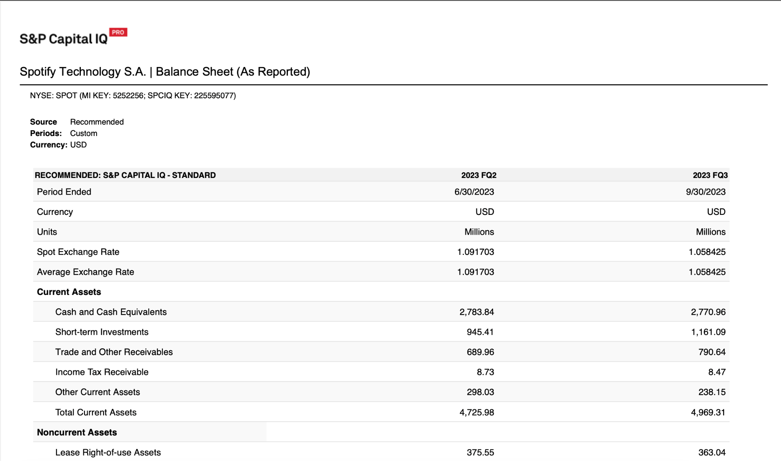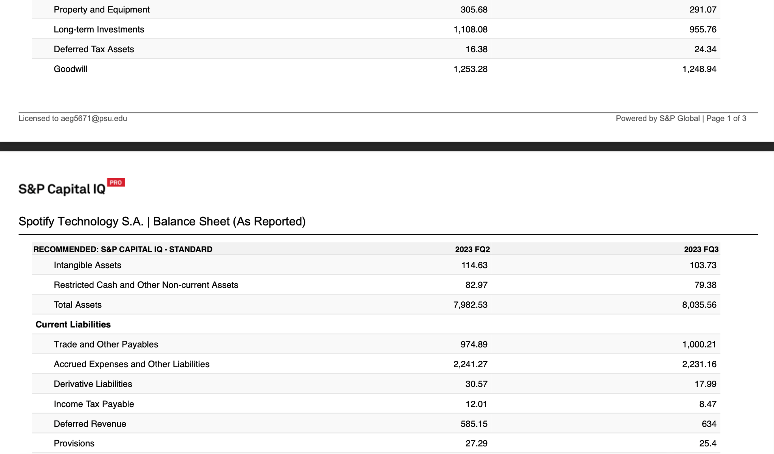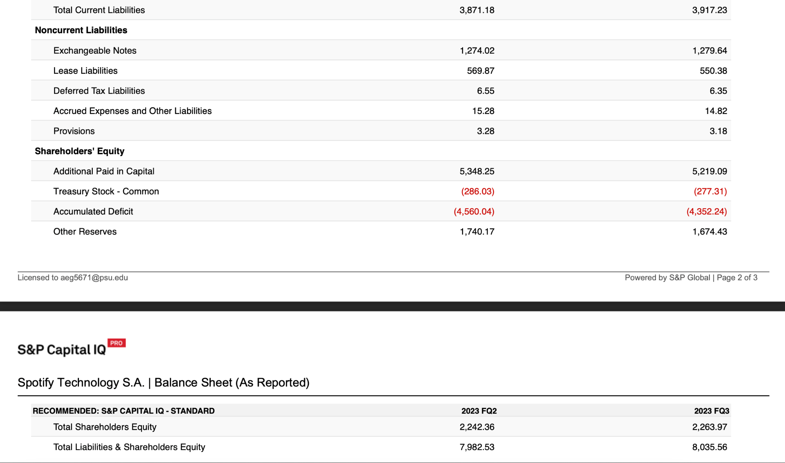

Balance Sheet **Source: S&P Capital IQ (SNL)**

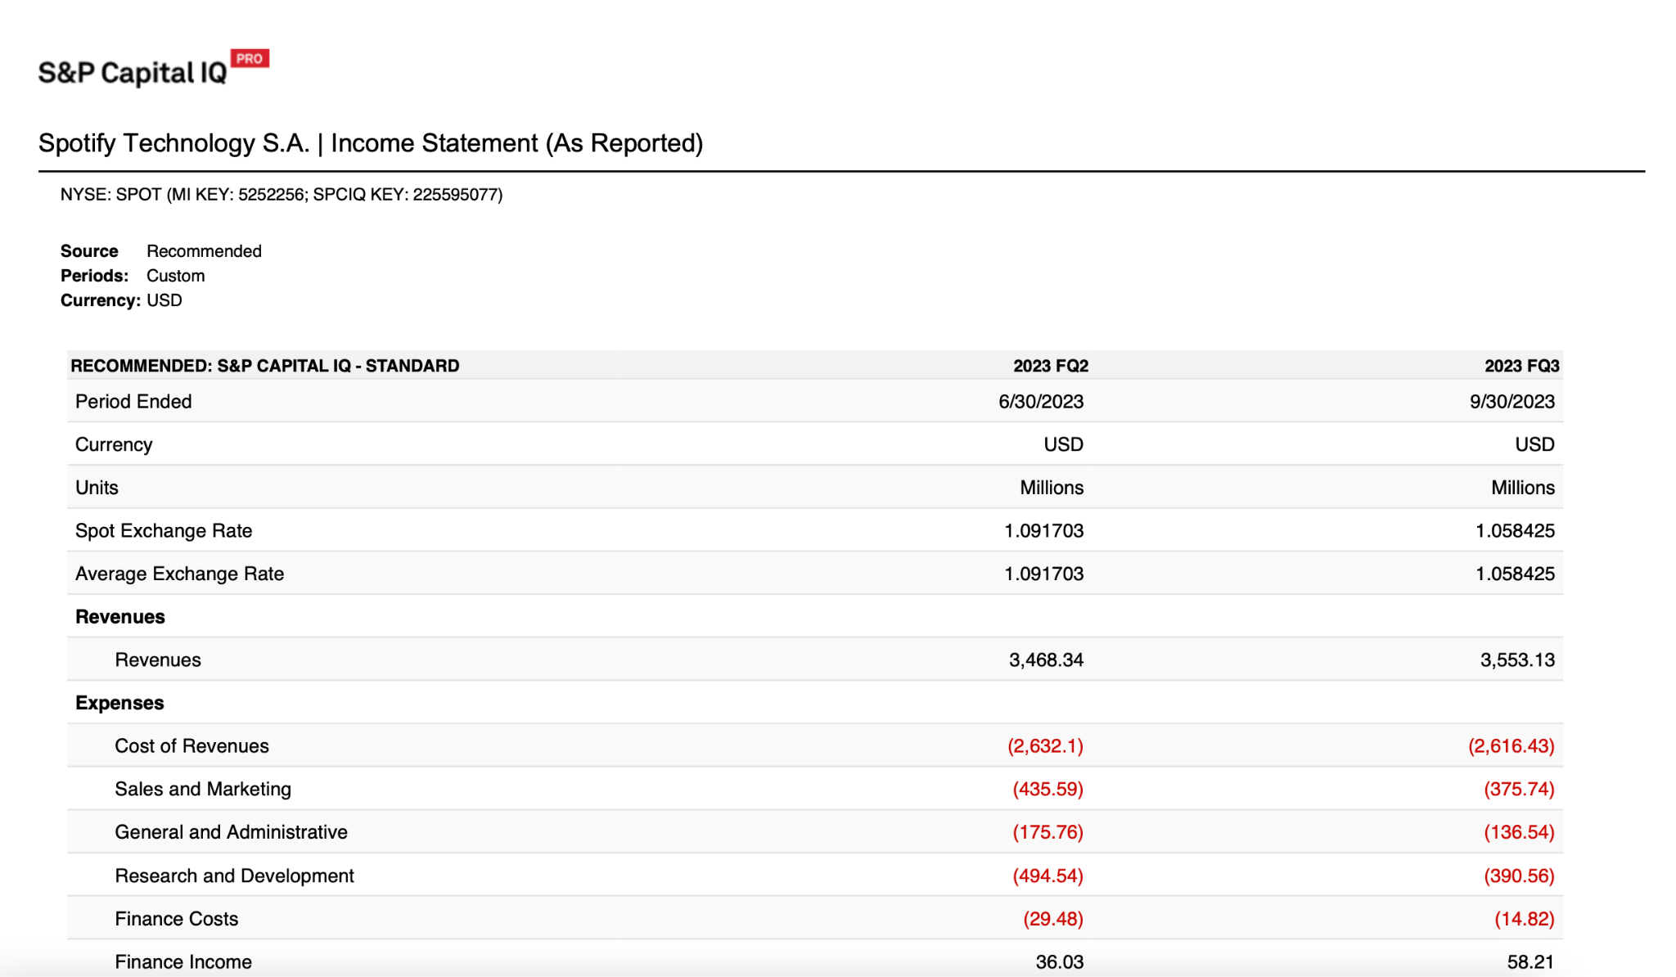

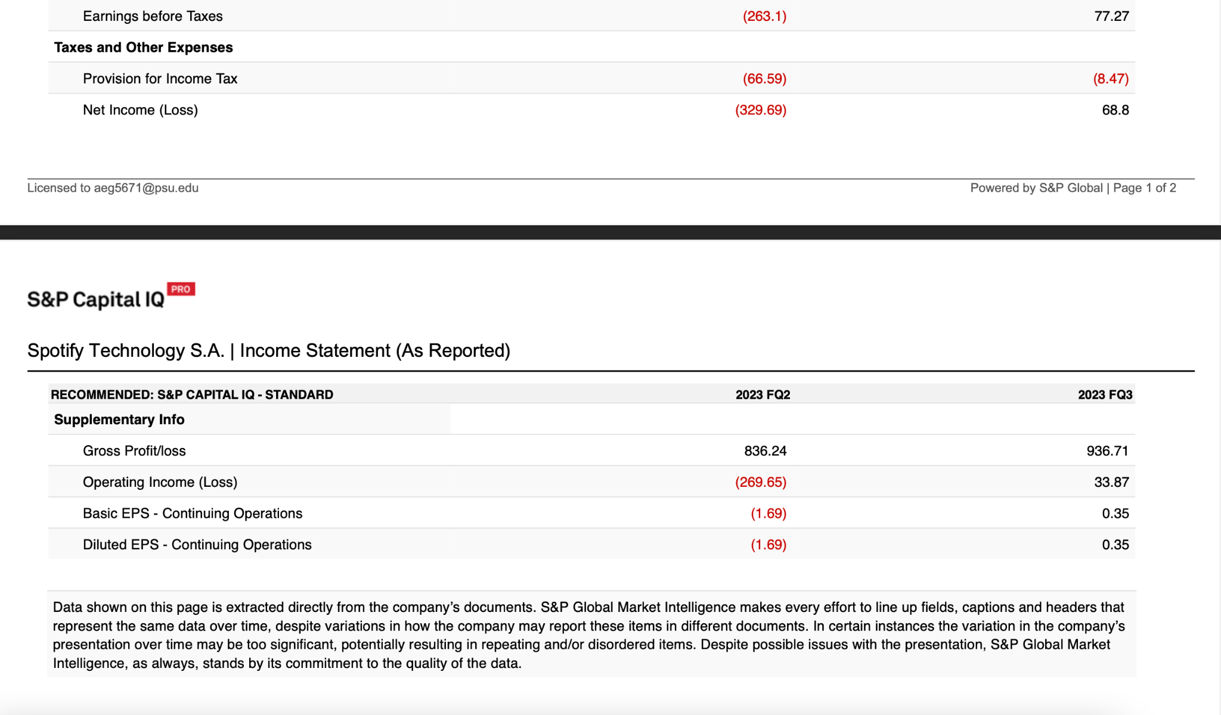

Income Statement **Source: S&P Capital IQ (SNL)**

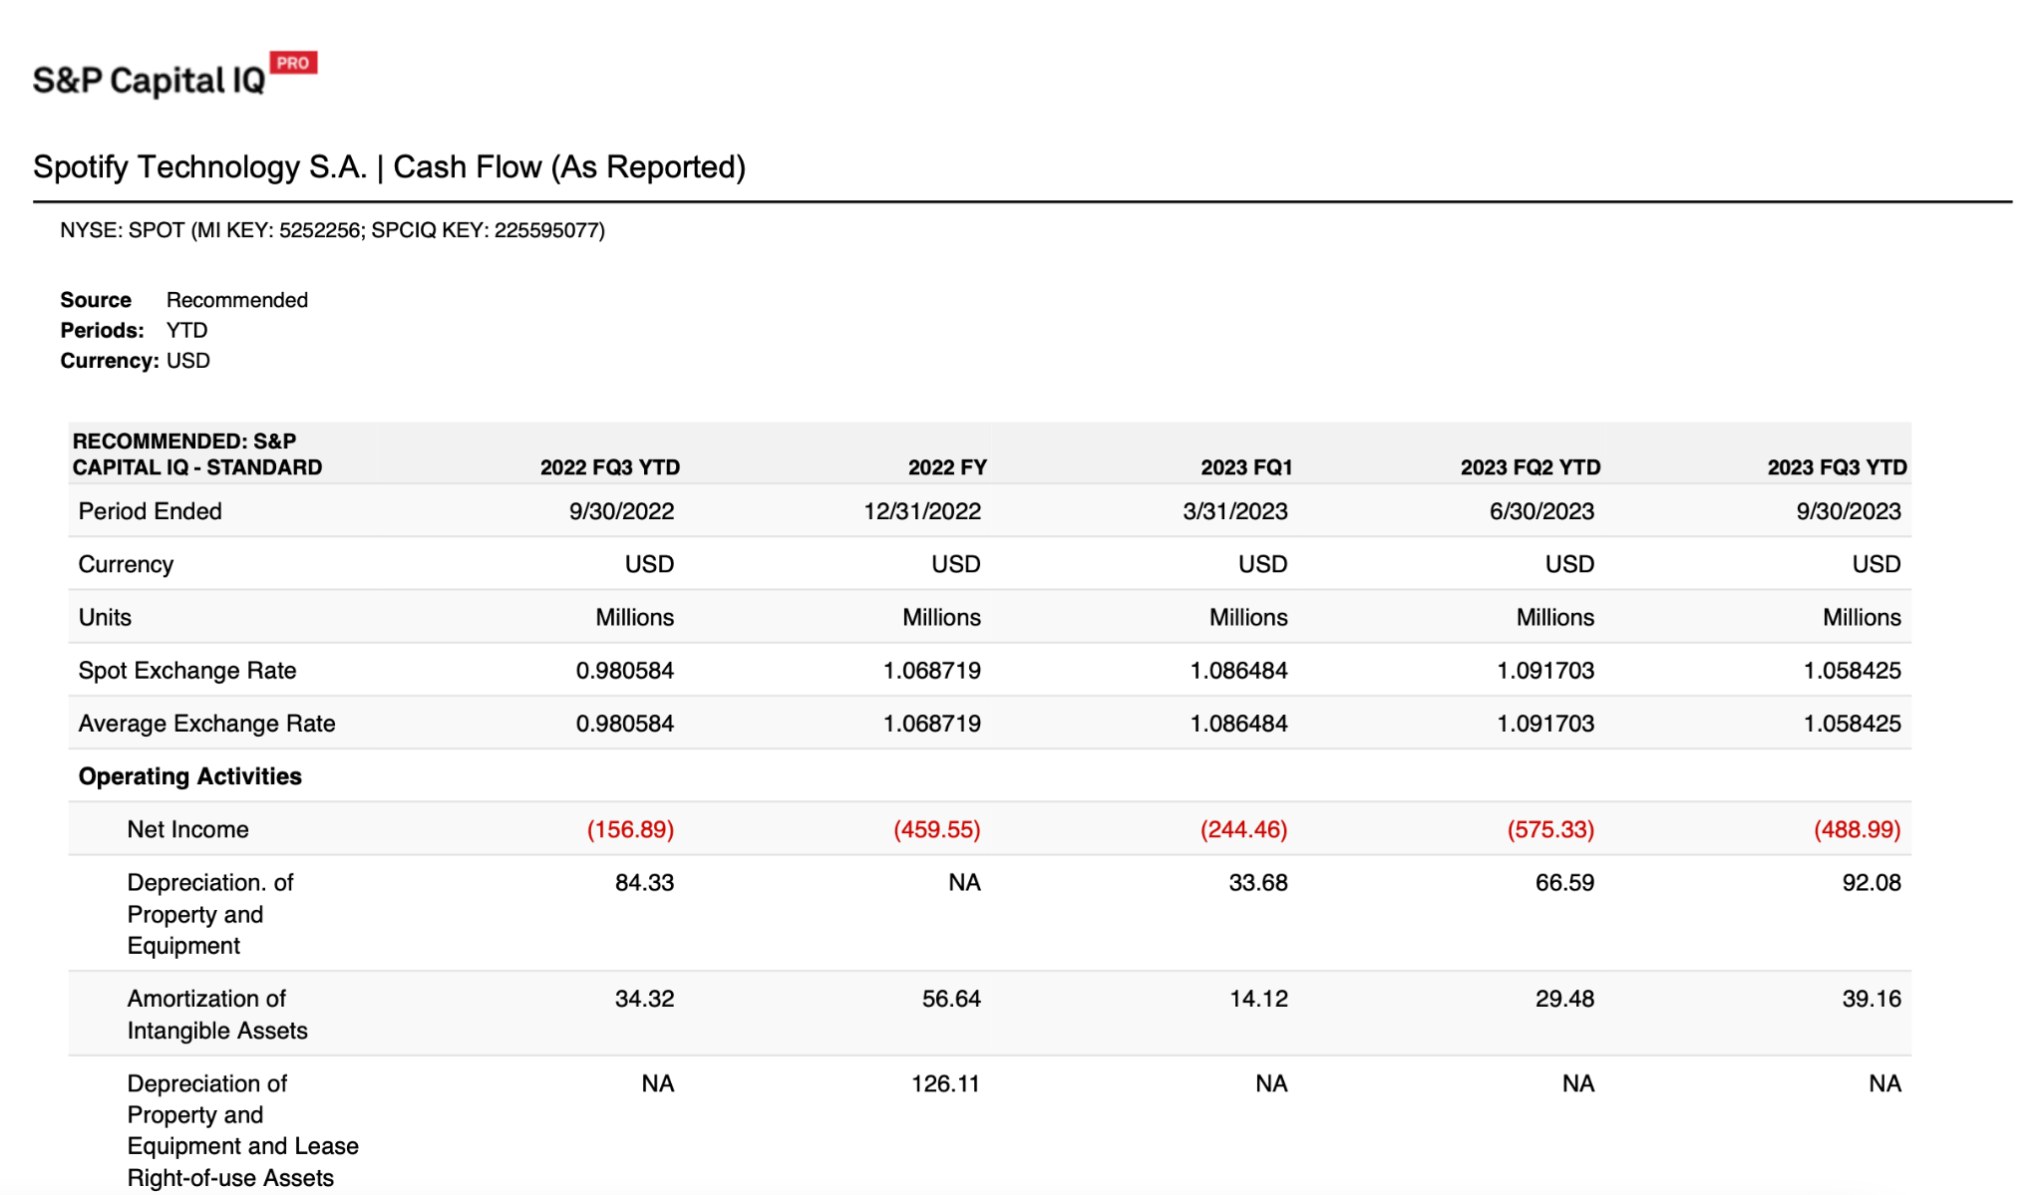

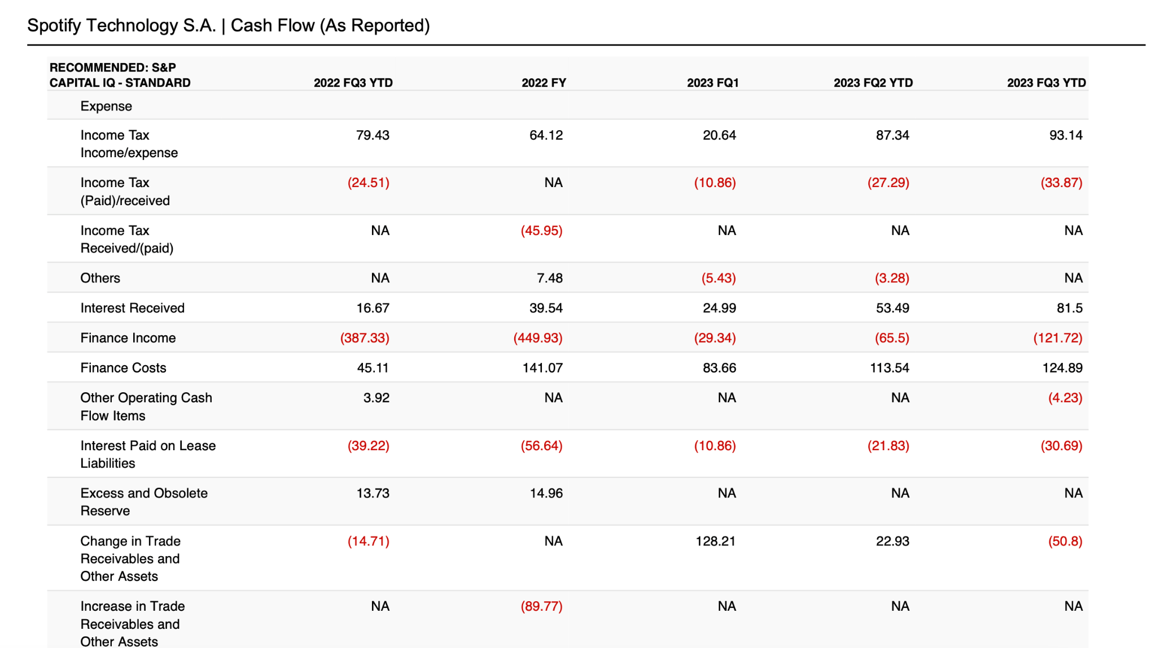

Statement of Cash Flows **Source: S&P Capital IQ (SNL)**

## 

## Section 2: Company Evaluation

The company’s existing leadership at Spotify has driven it to success and increasing streams of revenue. After examining the company’s existing leadership such as founders Daniel Ek and Martin Lorentzon, it is clear that their leadership has turned Spotify into the frontrunner it is today. (Yahoo Finance). They have implemented a range of new technologies and features into the platform to create a product that appeals to their target demographic and beyond, reaching global markets in an unprecedented way (Bengal Institute of Business Studies). I believe the composition of its leadership team and the way that Spotify structures their employees is a key indicator as to why Spotify is a key player in the music platform streaming industry. The agile organizational structure and the emphasis on teamwork, interpersonal communication, technological advancement, and quality of life updates to the platform have created a positive year financially for Spotify (Harvard Business Review).

The perceived company strategy for Spotify appears to be harnessing their existing popularity and brand recognition along with their proprietary advantages to create a custom user experience and product that customers keep paying for each month (Yahoo Finance). I found it particularly interesting how Spotify focuses on limiting media piracy and exclusive content within their platform, besides hosting a multitude of promotional offers (Richter). The things that distinguish Spotify from their competitors and have propelled their success include their custom features such as “Spotify Wrapped” and the new “DJ” feature which have pushed Spotify ahead of their opponents (Spotify S.A. 2023). I believe Spotify will continue to dominate the music streaming market for the next three years, as they continue to implement exciting features for their users and delve into the world of new technologies such as VR or AR (Spotify Design). I believe that these technologies will become an integral part of the Spotify platform over the timespan of the next three years.

References

*OD6193 - Music Streaming Services in the US*. At a Glance. (n.d.).

https://my-ibisworld-com.ezaccess.libraries.psu.edu/us/en/industry-specialized/od6193/at-a-glance

*About Spotify*. Spotify. (2023a, October 24). https://newsroom.spotify.com/company-info/

Alexander, S. (2023, December 9). *Daniel Ek: Swedish Entrepreneur* . Biography - Encyclopædia

Britannica. https://www.britannica.com/biography/Daniel-Ek

*Diversity, equity, Inclusion & Belonging: Life at Spotify*. Diversity, Equity, Inclusion & Belonging | Life at

Spotify. (n.d.). https://www.lifeatspotify.com/diversity-equity-impact/diversity-equity-inclusion-belonging

Forde, E. (2022, October 12). *Spotify comfortably remains the biggest streaming service despite its market*

*share being eaten into*. Forbes. https://www.forbes.com/sites/eamonnforde/2022/01/19/spotify-comfortably-remains-the-biggest-streaming-service-despite-its-market-share-being-eaten-into/?sh=360aa8893474

*From startup to global dominance: A deep dive into Spotify’s marketing strategy*. Bengal Institute of

Business Studies. (n.d.). https://www.bibs.co.in/blog/from-startup-to-global-dominance-a-deep-dive-into-spotifys-marketing-strategy

Frost, & Sullivan. (2022, November 7). *Technology advancement unfolds unprecedented opportunities for*

*the audio streaming services market*. PR Newswire: news distribution, targeting and monitoring. https://www.prnewswire.com/in/news-releases/technology-advancement-unfolds-unprecedented-opportunities-for-the-audio-streaming-services-market-301668772.html

Götting, M. C. (2022, January 18). *Spotify users by age in the U.S. 2018*. Statista.

https://www.statista.com/statistics/475821/spotify-users-age-usa/

Ingham, T. (2023, August 30). *Over-spending and under-pricing: Spotify’s commercial missteps have come*

*back to haunt it.* Music Business Worldwide. https://www.musicbusinessworldwide.com/over-spending-and-under-pricing-spotifys-commercial-missteps-have-come-back-to-haunt-it/

Levin, A. (2022, March 4). *Musicians organize around DMCA law, Time’s up for Spotify*. Observer.

https://observer.com/2022/03/musicians-organize-around-dmca-law-times-up-for-spotify/

*Making the brand: Redesigning Spotify Design*. Spotify Design. (n.d.).

https://spotify.design/article/making-the-brand-redesigning-spotify-design

Mankins, M., & Garton, E. (2017, February 9). *How Spotify Balances Employee Autonomy and*

*Accountability*. Harvard Business Review. https://hbr.org/2017/02/how-spotify-balances-employee-autonomy-and-accountability

Nicolaou, A. (n.d.). Streaming services urged to clamp down on AI-generated music.

https://www.ft.com/content/aec1679b-5a34-4dad-9fc9-f4d8cdd124b9

Richter, F. (2021, February 23). *Spotify Expands its Global Footprint*. Statista Daily Data.

https://www.statista.com/chart/24253/global-availability-of-spotify/

Sletten, R. T. (n.d.). *Spotify: Strategic plan and Analysis - University of Montana*. ScholarWorks at

University of Montana. https://scholarworks.umt.edu/cgi/viewcontent.cgi?article=1346&context=utpp

Snapes, L. (n.d.). Spotify To Phase Out Service In Uruguay Following New Copyright Bill.

https://entertainment.slashdot.org/story/23/11/22/0013215/spotify-to-phase-out-service-in-uruguay-following-new-copyright-bill#:~:text=Laura%20Snapes%20reports%20via%20The,%2C%20performers%2C%20directors%20and%20screenwriters.

*Spotify Expands to Six More Countries Around the World*. Spotify: For the Record. (2021, November 16).

https://newsroom.spotify.com/2021-11-17/spotify-expands-to-six-more-countries-around-the-world/

*Spotify marketing strategy: How Spotify won the market by vouching for “music for everyone.”* Buildd. (n.d.).

https://buildd.co/marketing/spotify-marketing-strategy

*Spotify reports third quarter 2023 earnings*. Spotify. (2023b, October 24).

https://newsroom.spotify.com/2023-10-24/spotify-reports-third-quarter-2023-earnings/

*Spotify Technology S.A. Public Company*. NYSE:SPOT (MI KEY: 5252256; SPCIQ KEY: 225595077).

(n.d.). https://www-capitaliq-spglobal-com.ezaccess.libraries.psu.edu/web/client#company/profile?id=5252256

*Spotify*. Cleverism. (2017, November 30).

https://cleverism.com/company/spotify/#:~:text=Specific%20partners%20include%20Coca%2DCola,so%20they%20can%20build%20apps.

Yurkevich, V. (2023, April 18). *Universal Music Group calls AI music a “fraud,” wants it banned from*

*streaming platforms. experts say it’s not that easy | CNN business*. CNN. https://www.cnn.com/2023/04/18/tech/universal-music-group-artificial-intelligence/index.html

Zacks Equity Research. (n.d.). *Alphabet’s (GOOGL) music streaming boosted with latest move*. Yahoo! Finance.

https://au.finance.yahoo.com/news/alphabets-googl-music-streaming-boosted-152803019.html?guccounter=1&guce_referrer=aHR0cHM6Ly93d3cuZ29vZ2xlLmNvbS8&guce_referrer_sig=AQAAAIQbqAV9I2K7xNkyizxvcQiK2wXo5kxSHRGcpMUBa0WLNyuLlqCsjZ0JoWhqJOG6M4lonJ094XtERFRkLPKbx6zyGkYQUVUvSiFg_rUZVpfCvjuZGBheL_1HcjR-g8XIq1skqeExWx22HhWPuRJZgUaR8hrUzR-8D3tRl1QrKr1-

## 